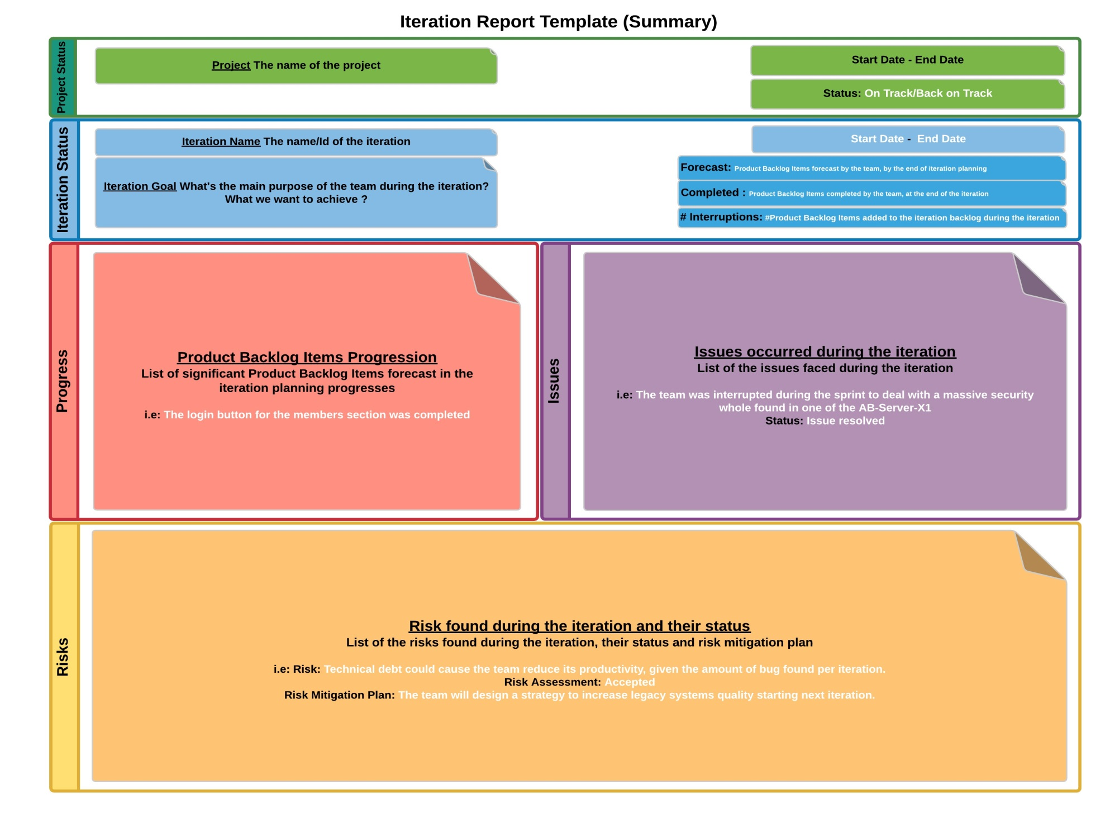
Project Status | Project | Start Date – Estimated end date
 |  | Status:
Iteration Status | Iteration Name | Start Date – End Date | Team Name | Scrum Master
 | Iteration Goal | Forecast:
 |  | Completed:
 |  | #Interruptions (Added):
Progress |  | Issues
Product Backlog Items Progression  - Product Backlog Item XXXX was completed.  - I.E. For more details about what was completed during the iteration, click here (Release notes) |  | Issues occurred during the iteration  - The team was able to complete what was forecasted at the beginning of the sprint, congratulations!
Risks
List of Potential risks found during the iteration and their status
- The amount of Technical debt accumulated in the RoudSystem project is huge, up to a point that developers are having a hard time to support the system properly. Given that, there is a risk of a having the system down for a long period if it never breaks down.
  - Risk Assessment: Impact(High), Likelihood(High)
  - Response: Accepted
  - Summary: The team suggested bringing external reinforcement to mitigate the risk, so the company is currently discussing with Patrick Lemieux about a potential support contract for RoudSystem. To follow up during upcoming iterations.

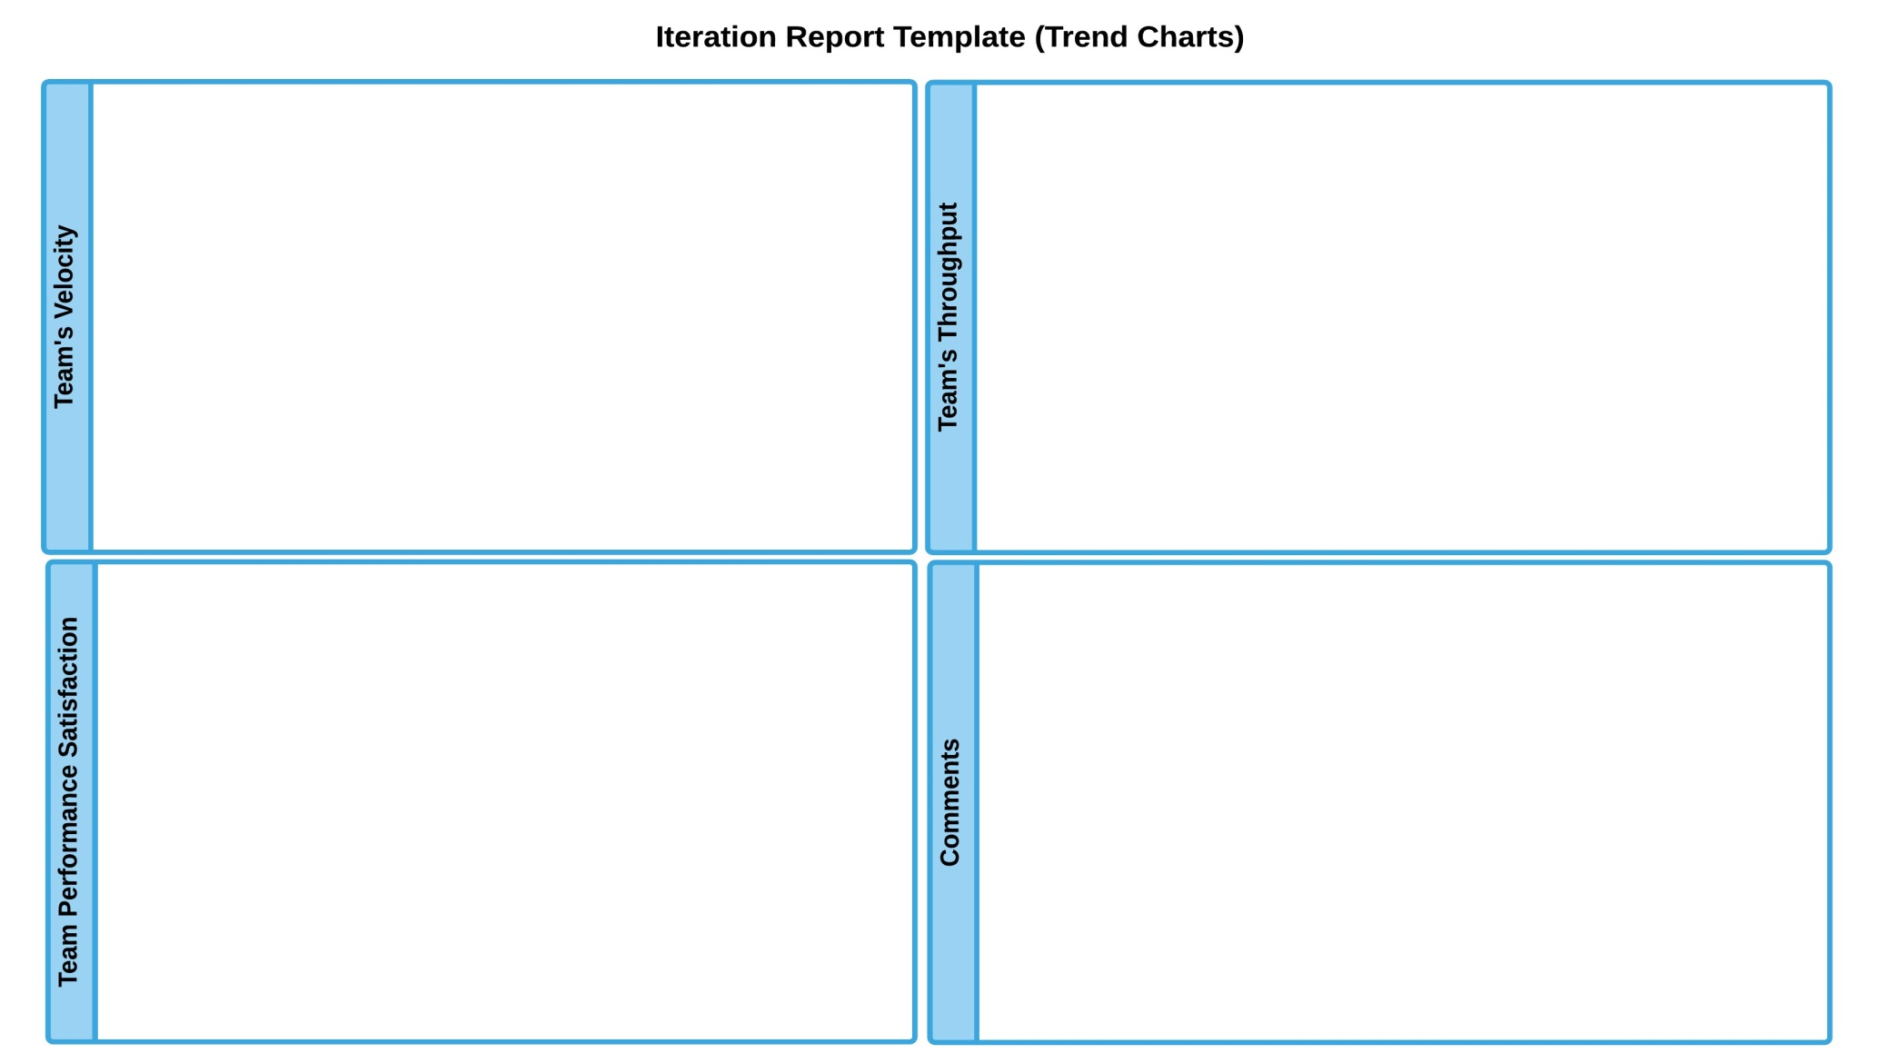

Velocity
Notes: As you could see in the “Velocity” charts, Median velocity it’s still unstable, and it will be like it for at least three sprints more.

Team’s Performance Satisfaction Score
Notes: Stakeholders Team’s Performance Satisfaction Score has shown that they are “HAPPY” with how the team is doing. By the other hand, the Scrum Team seems to be “OK” with their performance, so there is work to do to increase the level of team`s performance satisfaction, even if the Scrum Team recognize how things have improved.

